Test system with 10 users
- Label-detected allergens (gluten + dairy + soy)
Purpose: Check that OCR/label allergen detection functions and that the identified allergens are combined with meal filtering (automatically avoiding gluten, dairy, and soy meals).
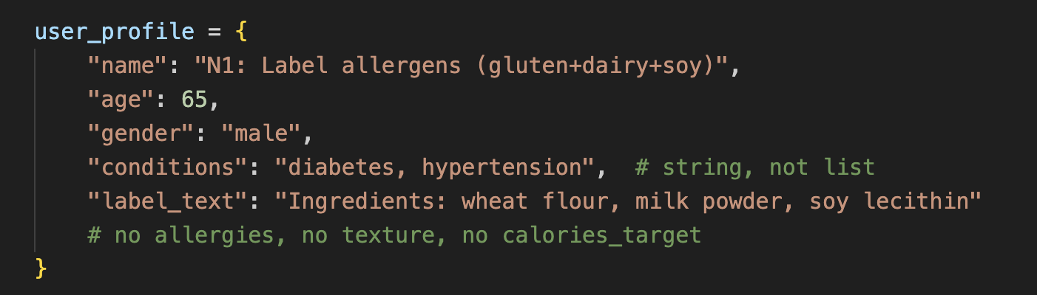
Output:
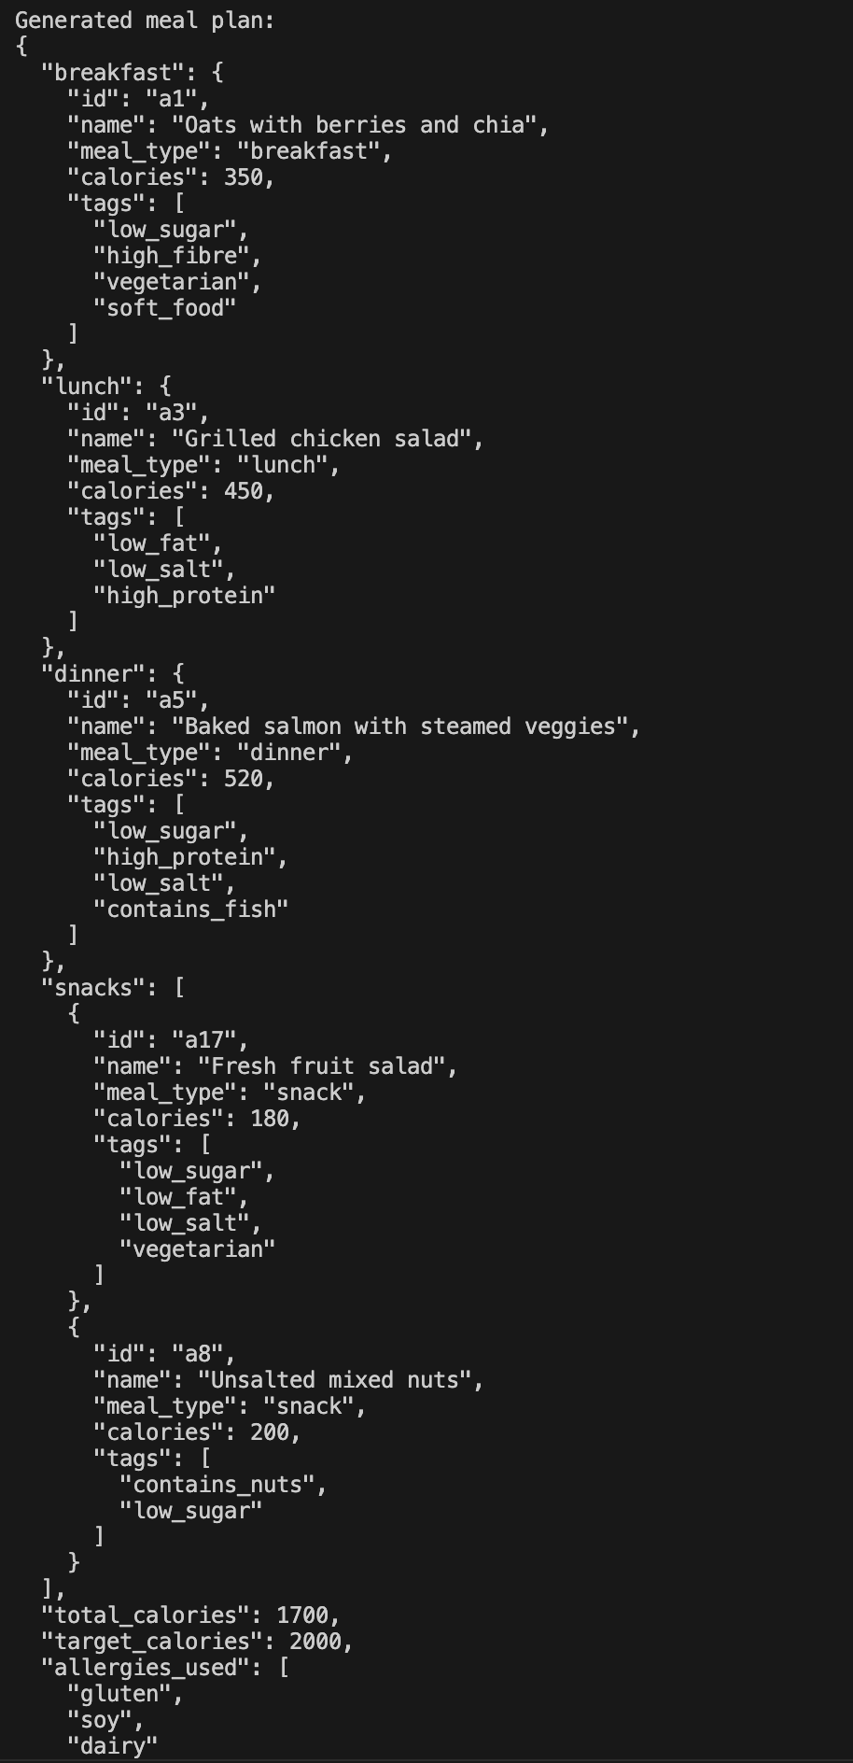
- Peanut allergy
Purpose:
- Test the following simple user-inputted allergy mapping: peanut → contains_peanut + contains_nuts
- Make sure snacks and meals like nuts are prohibited.
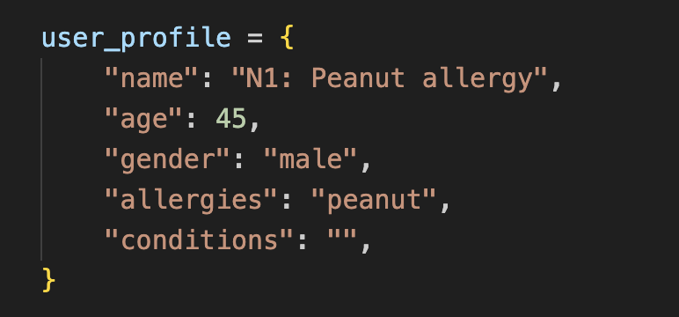
Output:
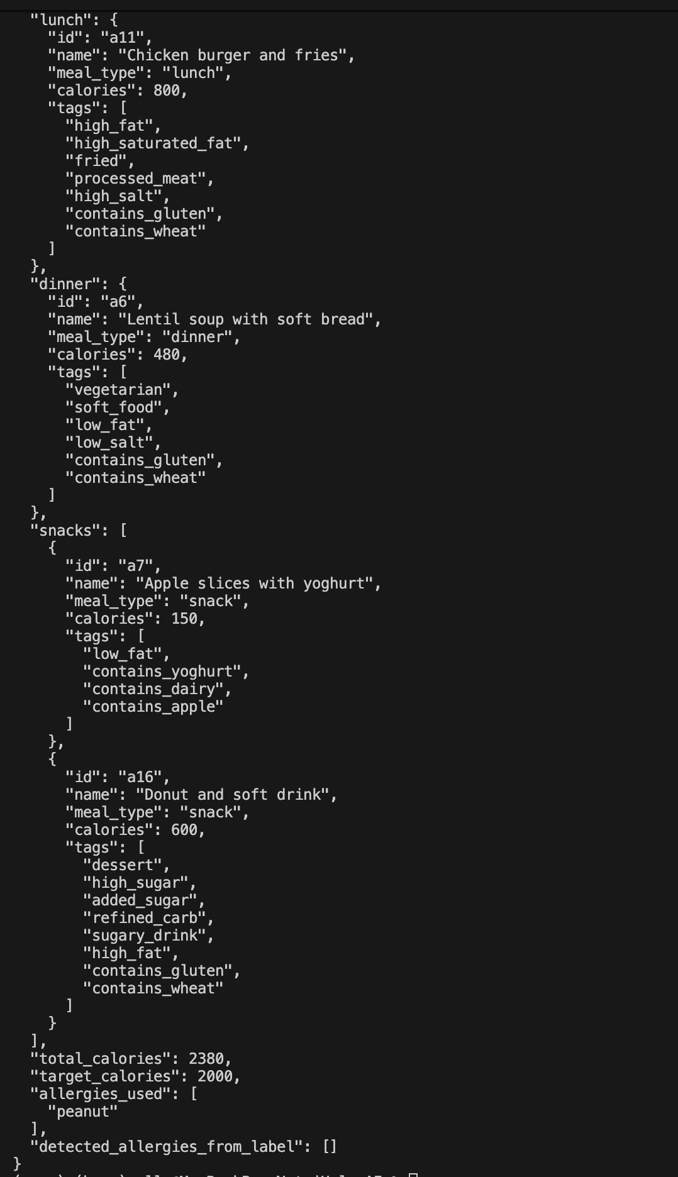
- Nuts + Dairy allergy
Purpose:
- Test handling of many allergens simultaneously and list input (not just string).
- Any meal with dairy or nut tags should be blocked, as should snacks like yogurt and almonds.
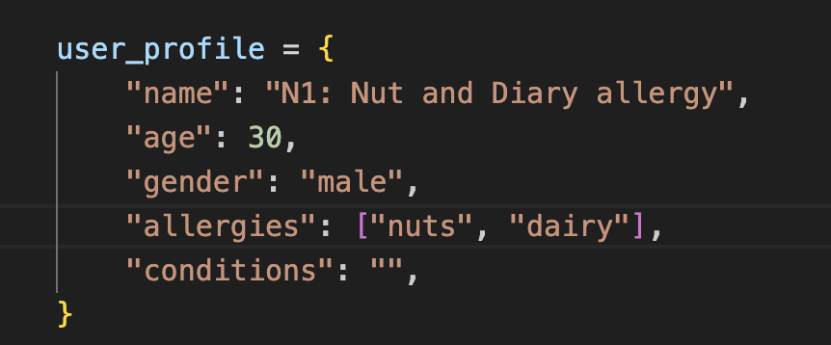
The output:
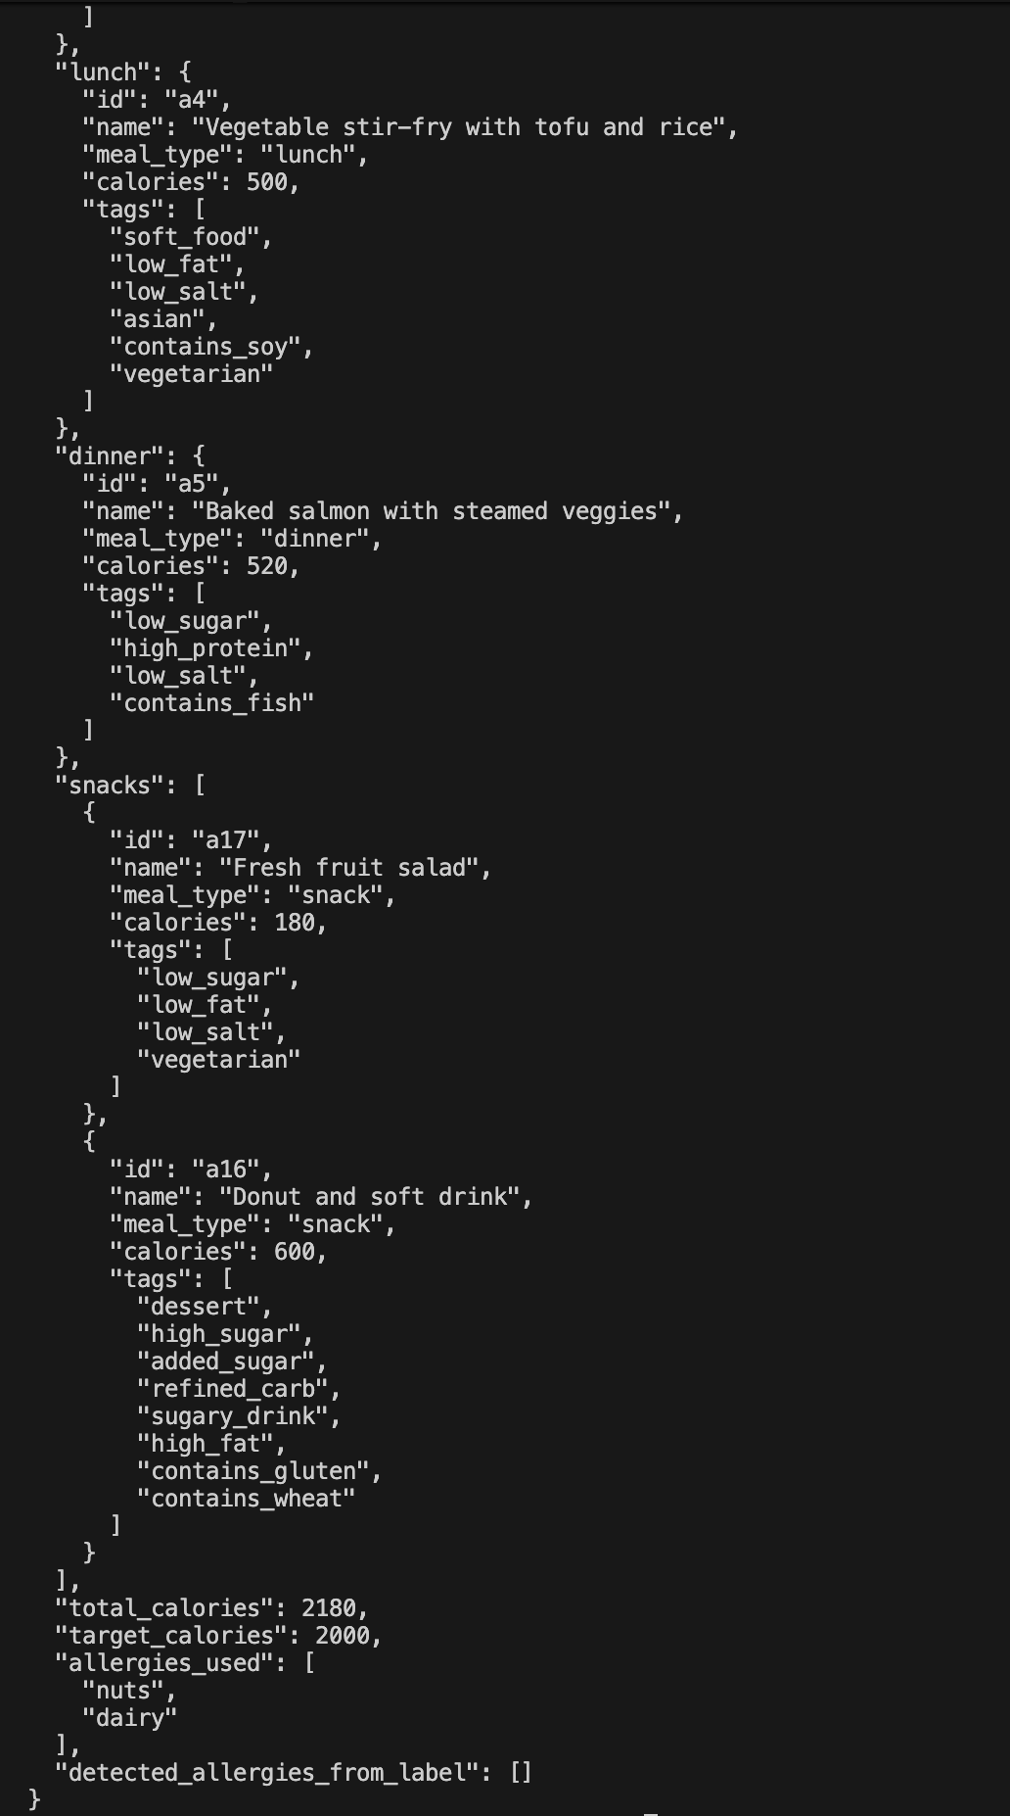
- Fish allergy
Purpose:
- For finned fish meals, such as salmon dishes with contains_fish, test seafood filtering.
- Checks that meals containing fish are not included.
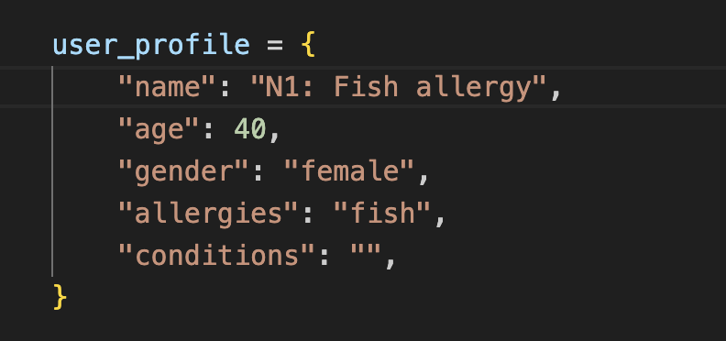
The output:
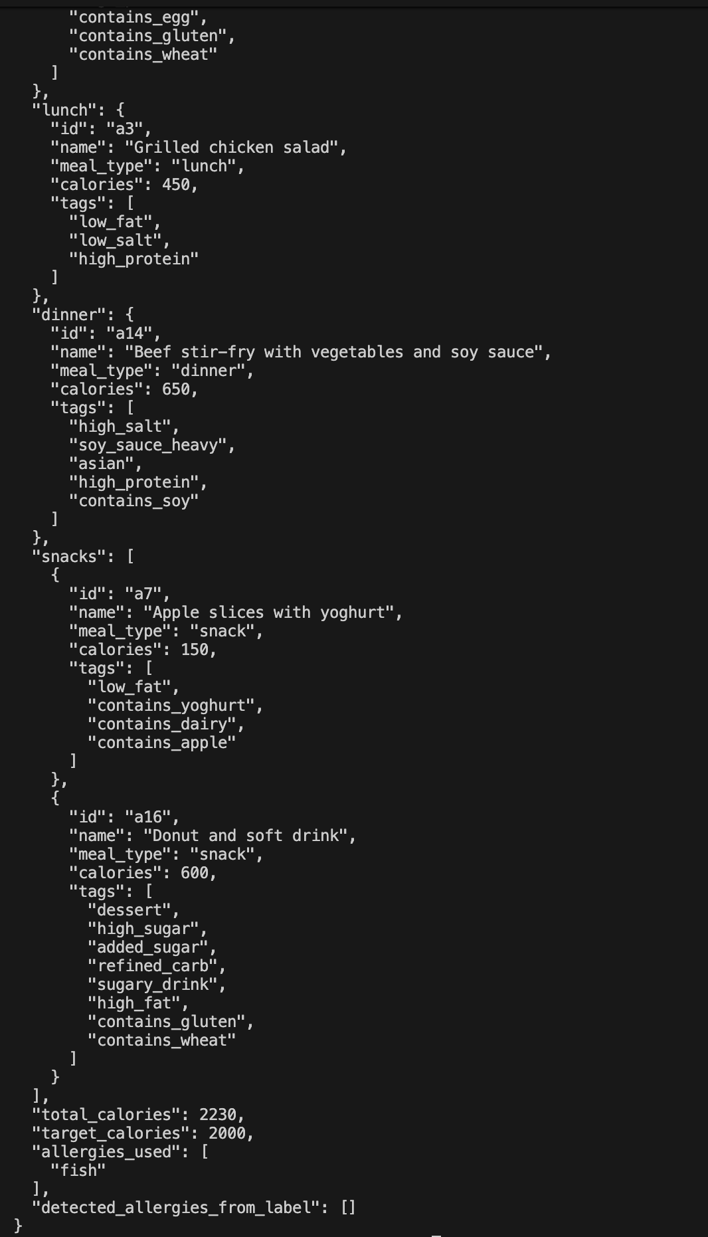
- Shellfish allergy and Hypertension
Purpose:
- Test the combination of the condition filter and the allergy filter.
- Shellfish meals and high-salt meals (processed, pickled, or heavy in soy sauce) should be eliminated.
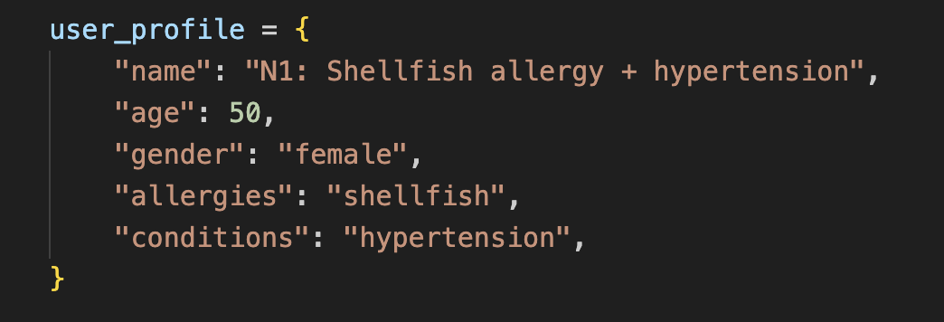
The output:
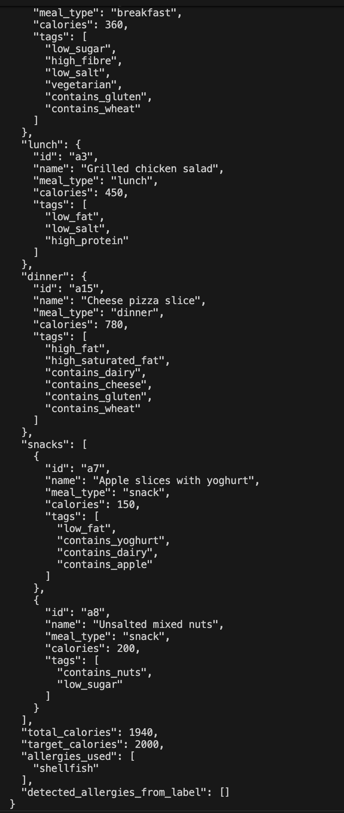
- Gluten allergy + Diabetes
Purpose:
- Combine the diabetic and allergy rules.
- Avoid gluten-containing foods as well as diabetes "bad tags" like dessert, high sugar, and high GI.
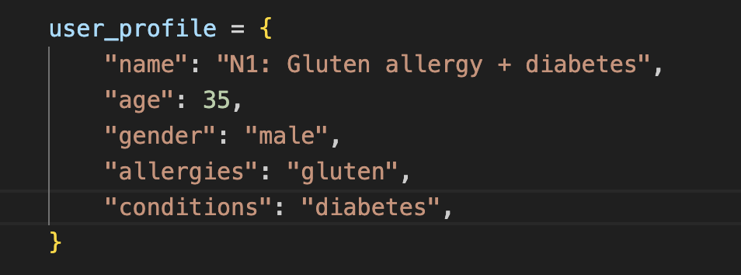
The output:
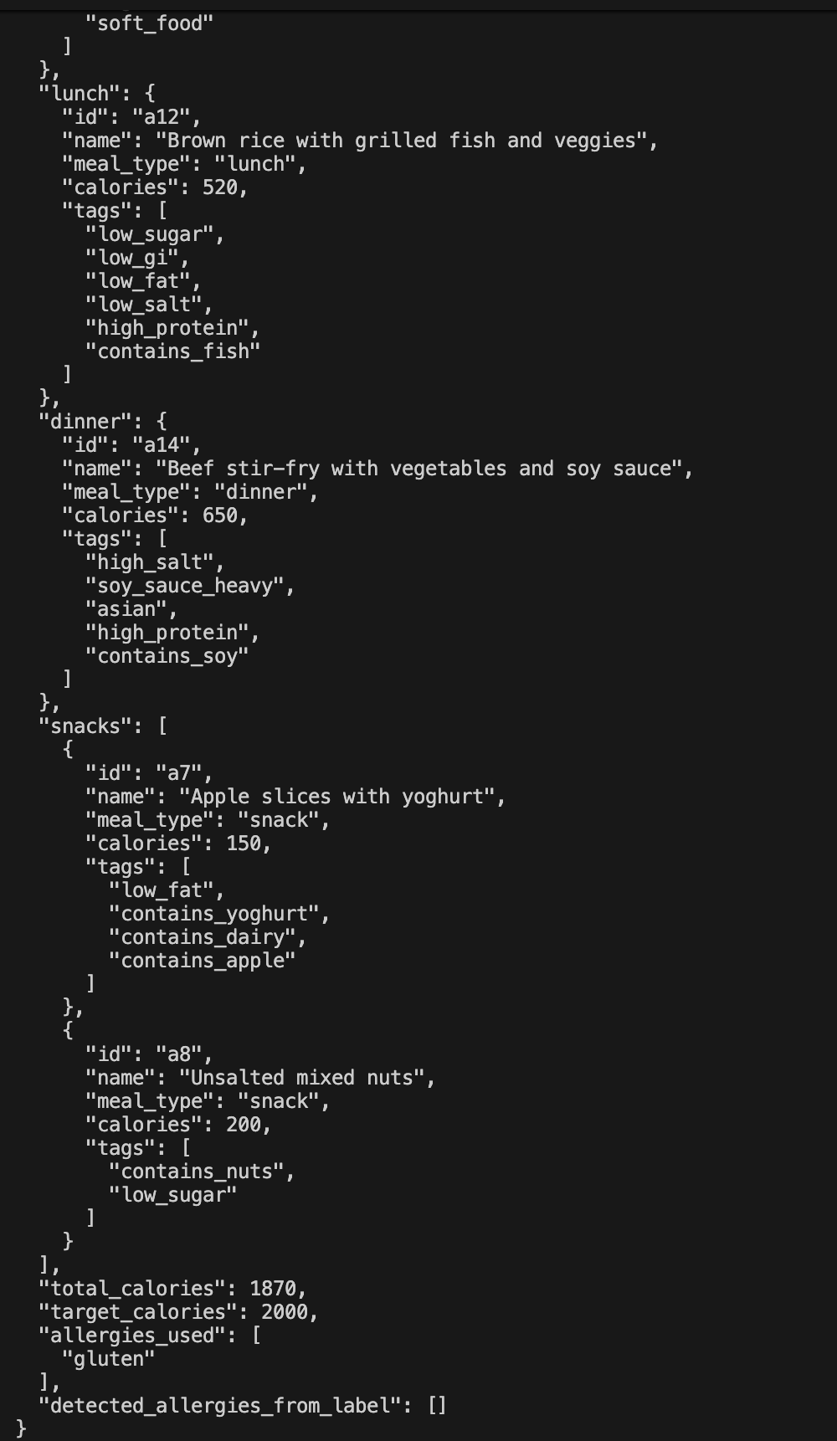
- Fruit allergy (apple + strawberry)
Purpose:
- Examine how your ALLERGY_MAP fruit tags, such as contains_apple, handle fruit allergies.
- Make sure fruit snacks, such as "apple with yoghurt," are not included.
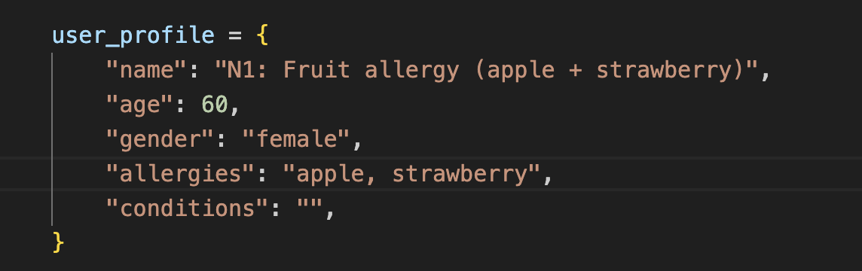
The output:
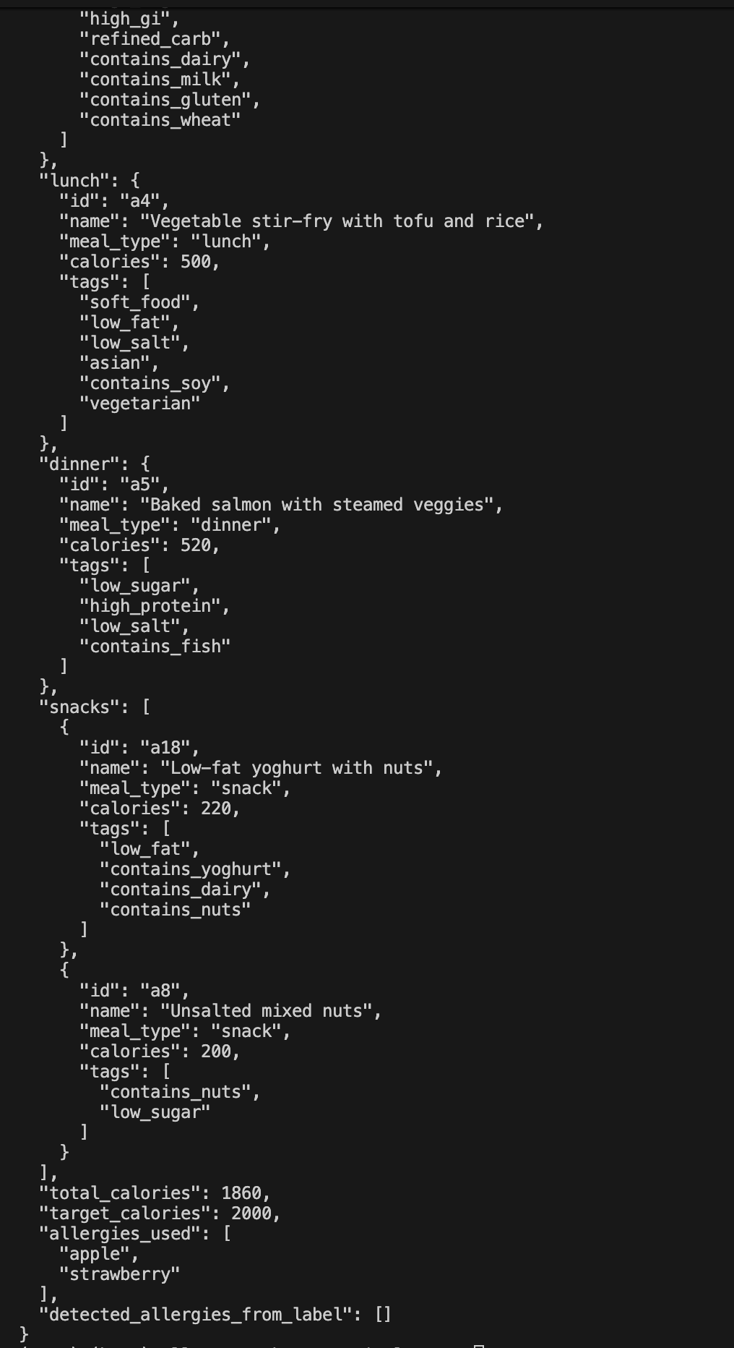
- Elderly + Soft texture requirement
Purpose:
- Make sure the meals selected are soft foods when they are available by using texture logic and senior preference.
- Verify that my elderly rule is operating correctly.
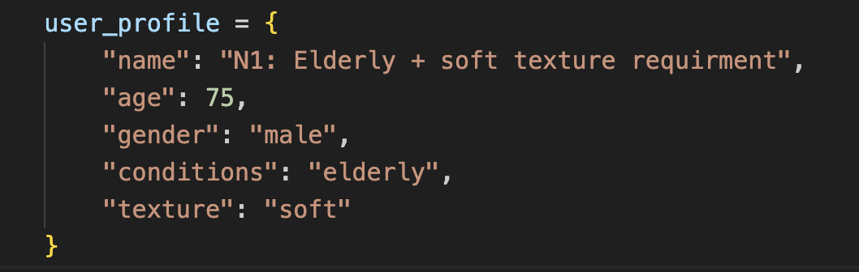
The output:
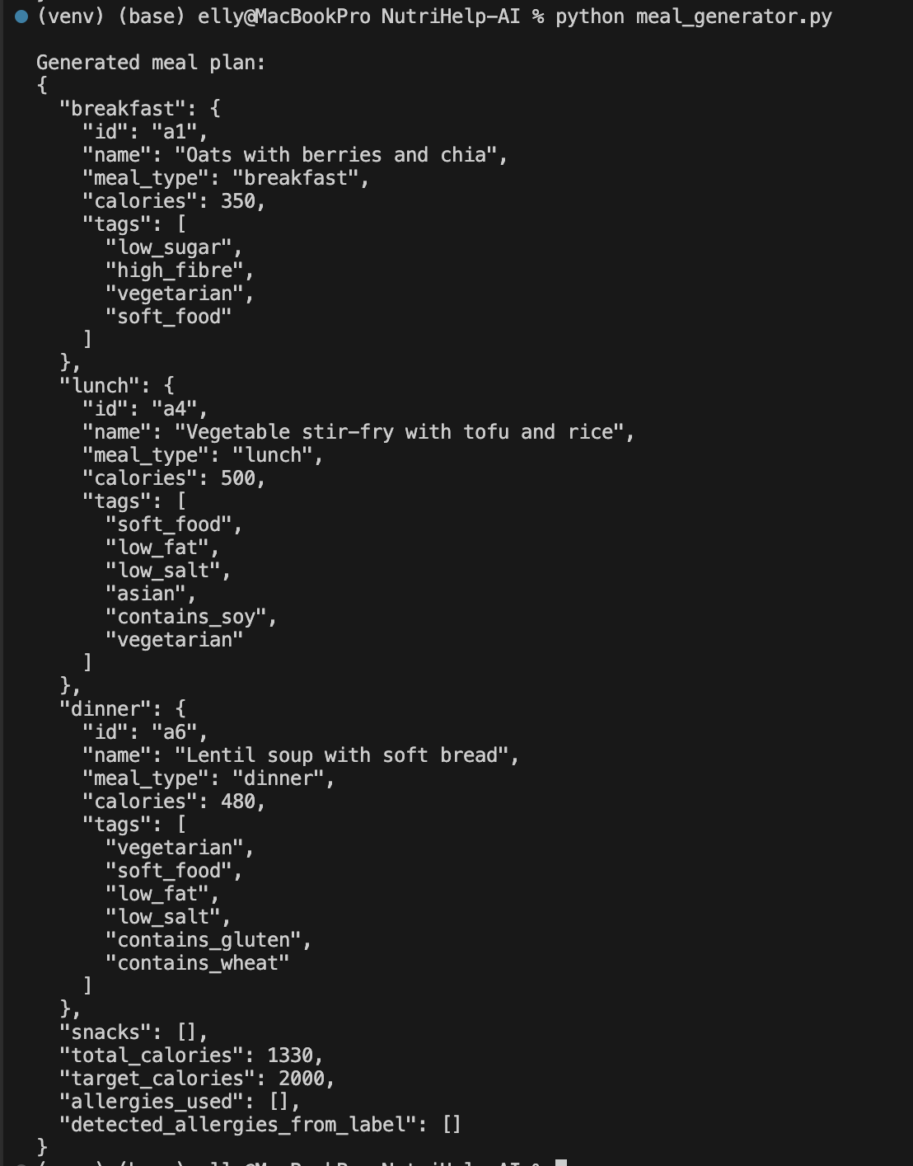

- CKD / Kidney disease
Purpose:
- Kidney disease test condition filter (avoid tags like high_protein, high_potassium, high_phosphorus).
- Make sure meals high in protein are screened out.
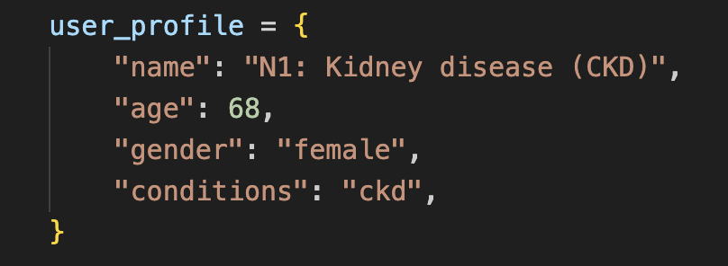
The output:
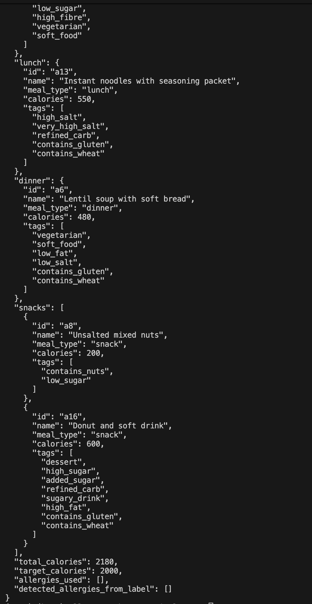
- Label-detected seafood + citrus
Purpose:
- Verify that filtering prevents meals and snacks with contains_shellfish or citrus tags (if you inserted citrus keywords) and test allergy detection from the label for shellfish + citrus.
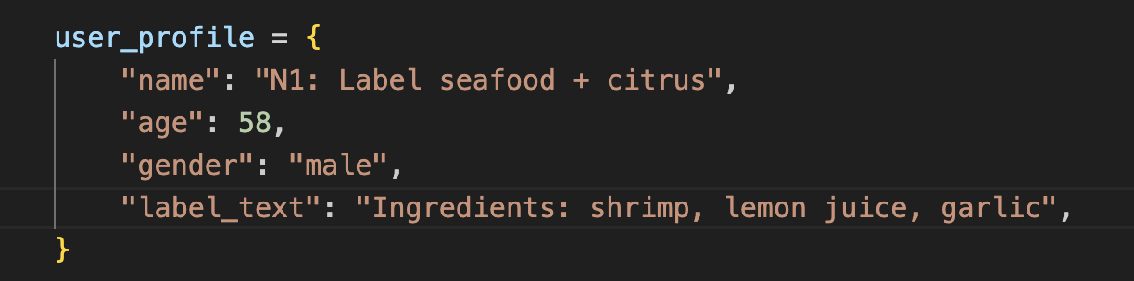
The ouput:
